Installation guide Misty

This guide is to help you install all the necessary software to successfully work on the assignments of the HRI course. If you encounter any errors or other problems, contact Raymond (r.h.cuijpers@tue.nl). The files that are mentioned in this manual can all be found in Canvas, under the “Software” module.

Currently, there are three methods to access the robot:
- Python 3.x. Version 3.11 or higher should be fine for most situations. Older packages sometimes so not work with the newest Python 3 version.

Installing Python 3.11
After installing python 3.11 or higher, go to your python distribution and create a virtual environment
- Go to your command shell and type python –version and check the version is >=3.11
- Create a virtual environment https://www.w3schools.com/python/python_virtualenv.asp and activate it. If you are using anaconda use conda instead https://docs.conda.io/projects/conda/en/latest/user-guide/tasks/manage-environments.html
- Install python packages: numpy, scipy, matplotlib, opencv and libqi-windows. Libraries are correctly installed if you can import them from Python e.g. import numpy as np.

pip install numpy scipy matplotlib
pip install opencv-python
pip install libqi-windows

Note: On windows you sometimes need to type python -m pip install <packagename>
Note: On windows you may need to use py3 instead of python

Misty Robot
To access the misty robot from python you need to install Misty-SDK for Python version 3.8 or higher. Note that this is not Python 2.7, which was needed for the Nao and Pepper robot. So you need to use a Python 3.8 or higher installation and create a separate virtual environment (see e.g. https://packaging.python.org/en/latest/guides/installing-using-pip-and-virtual-environments/ ).
Open the command shell for your Python 3 distribution and install mistyPy:
pip install git+https://github.com/MistyCommunity/Python-SDK.git
• Do not use “pip install mistyPy”, it is outdated
Details on how to use this package can be found here: https://github.com/MistyCommunity/Python-SDK
As for the nao robot you should install other useful libraries as needed:
pip install numpy scipy matplotlib
pip install opencv-python
Connecting to Misty
Set up the router (Generally done by Tutors)
Plug in the ethernet cord (if ports are available in the building)
If this is not available, you and Misty won’t have an internet connection.
Need to look something up on the internet? Temporarily switch back to TU/e network or use another device.
Plug in the power cord
Connect: Password and SSID on the bottom of router

Connect to the web interface
http://192.168.0.151/ in your browser
Sometimes it’s a different IP address. We are working on this!
Does the video feed show what you expect, and does it update?

Web Interface
Open the web browser and go to Misty’s ip-address, usually 192.168.0.151
Enter your robot's IP address in the upper-right hand corner of the page and click the Connect button
a lab/room (Atlas building only) for using the robot using cluster market
Works the same as equipment
Notify the appropriate HTI staff member/Lab support
Only when it is accepted you an receive the robot(s)

sing Python and mistyPy

Python and mistyPy Installation (1) – Anaconda
- Install Anaconda Navigator
  - https://www.anaconda.com/docs/getting-started/main.
  - Pick `Anaconda Distribution for Windows`
  - This can take a while, don’t be alarmed if it seems to “hang”

- (Recommended) Create and activate a new virtual environment
  - https://www.anaconda.com/docs/tools/anaconda-navigator/tutorials/manage-environments
  - Go to “Environments” and click “Create”
  - Use python 3.13.11 (latest version gives error in notebook install)
  - Activate the environment by double clicking it
- Go to home, and press “Install” on “anaconda_prompt”, “Jupyter notebook”, and “Spyder”
- Start “anaconda_prompt”
  - install git:
conda install anaconda::git
conda install spyder-notebook –c conda-forge
  - install mistyPy:
pip install git+https://github.com/MistyCommunity/Python-SDK.git
Do not use “pip install mistyPy”, this version is outdated and uses a different naming convention
- Start “Spyder” and follow the brief tutorial.
  - This is your Python programming environment, also called the Interactive Development Interface (IDE).
  - Leave Spyder open for now.

Testing if it works
Connect to the router’s WIFI with your laptop
It may take a few minutes for the router to start up.
You can only access the internet if the router is plugged in to Atlas’s network.
Without internet, almost everything still works.
Start the robot
Button on the bottom
See “Working with Misty” slide
Connect to the ip address of misty in your browser
Currently: ask lab support or the tutors for the IP address. We are working on this!
Is your browser seeing through Misty’s camera?
And is this the correct Misty?

Start Spyder-notebook and test!
Open Anaconda Manager
Select the correct environment in “Environments” and Start “Spyder” in “Home”
“Undock” the spyder-notebook pane (see image)
Open the example code
https://github.com/Rctue/misty-lib/blob/main/basic_example.ipynb
Pop out the Spyder-Notebook pane and open the basic example notebook
Check if you can use Misty
Is no one else working with Misty?
Work through the Spyder-notebook
Can you make it work in a normal .py file?

More lessons and documentation

Check all available functions:
https://lessons.mistyrobotics.com/python-elements/misty-python-api

Can you complete the lessons?
https://lessons.mistyrobotics.com/python/python-lessons/lesson-1-loco-motion

Detailed picture guide (1)
Install Anaconda Navigator
https://www.anaconda.com/docs/getting-started/main.
Pick `Anaconda Distribution for Windows`
This can take a while, don’t be alarmed if it seems to “hang”
Default settings are okay
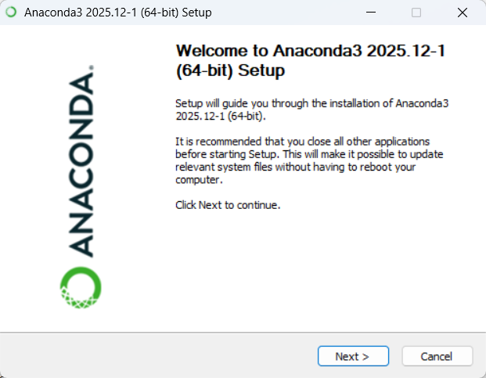
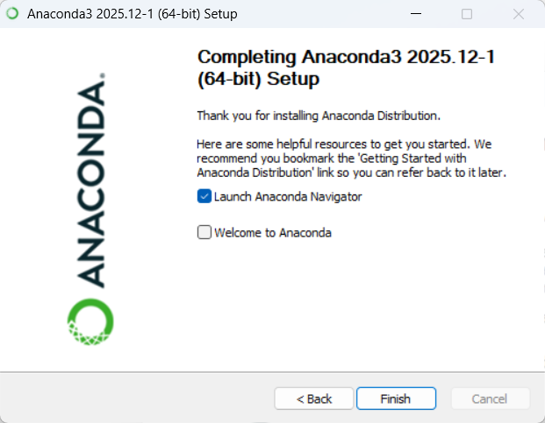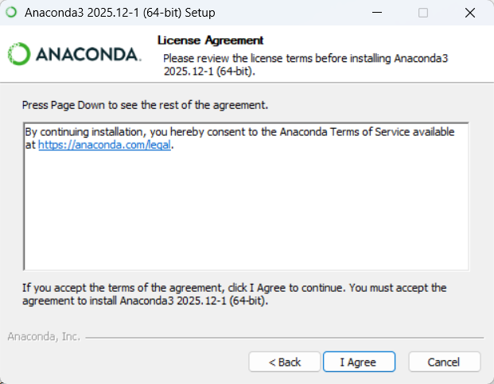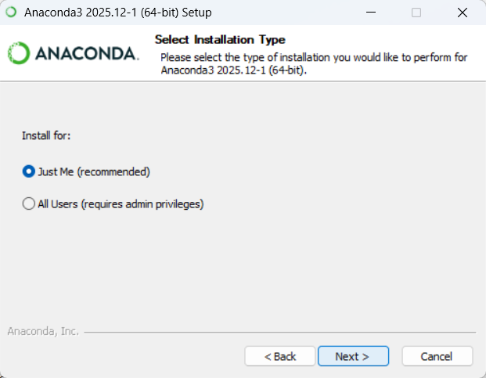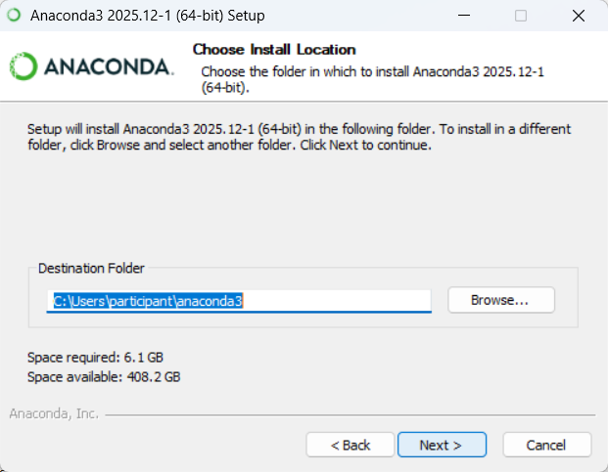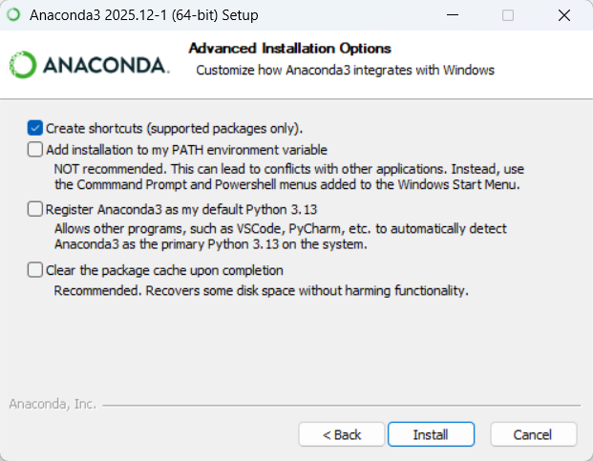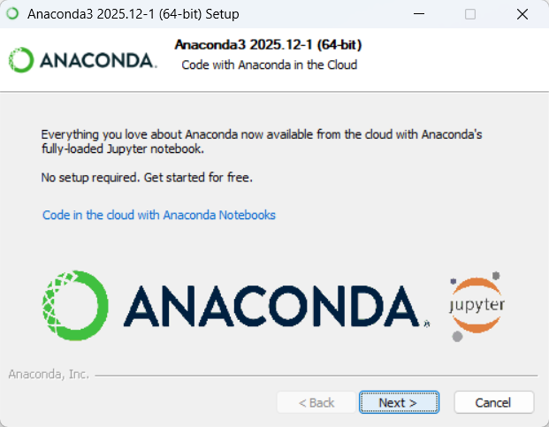

(Recommended) Create and activate a new virtual environment
https://www.anaconda.com/docs/tools/anaconda-navigator/tutorials/manage-environments
Go to “Environments” and click “Create”
Use python 3.13.11 (latest version gives error in notebook install)
Activate the environment by double clicking it
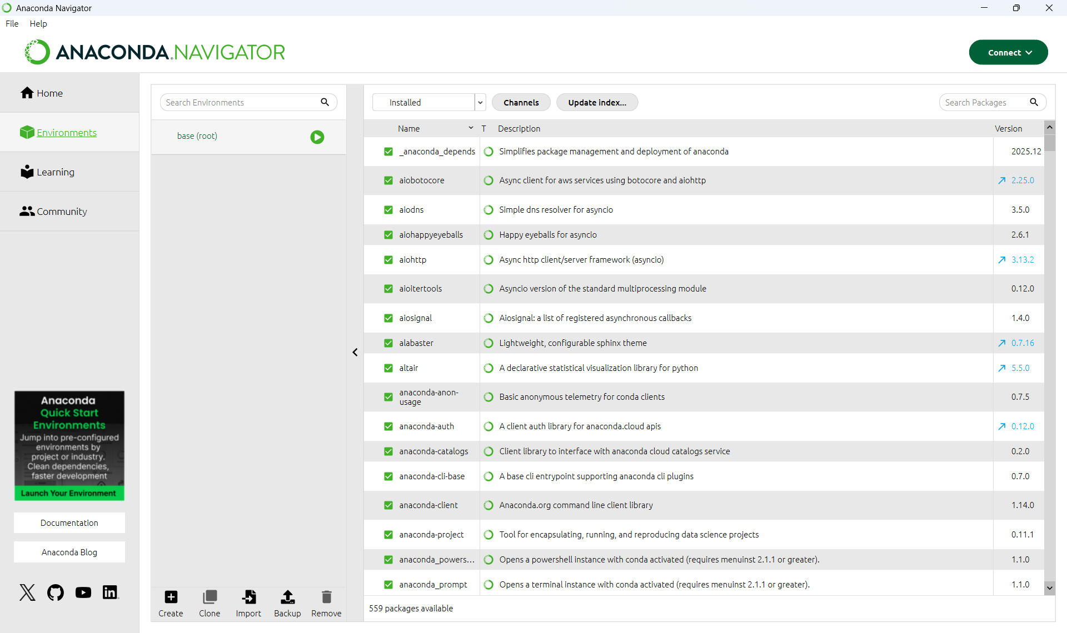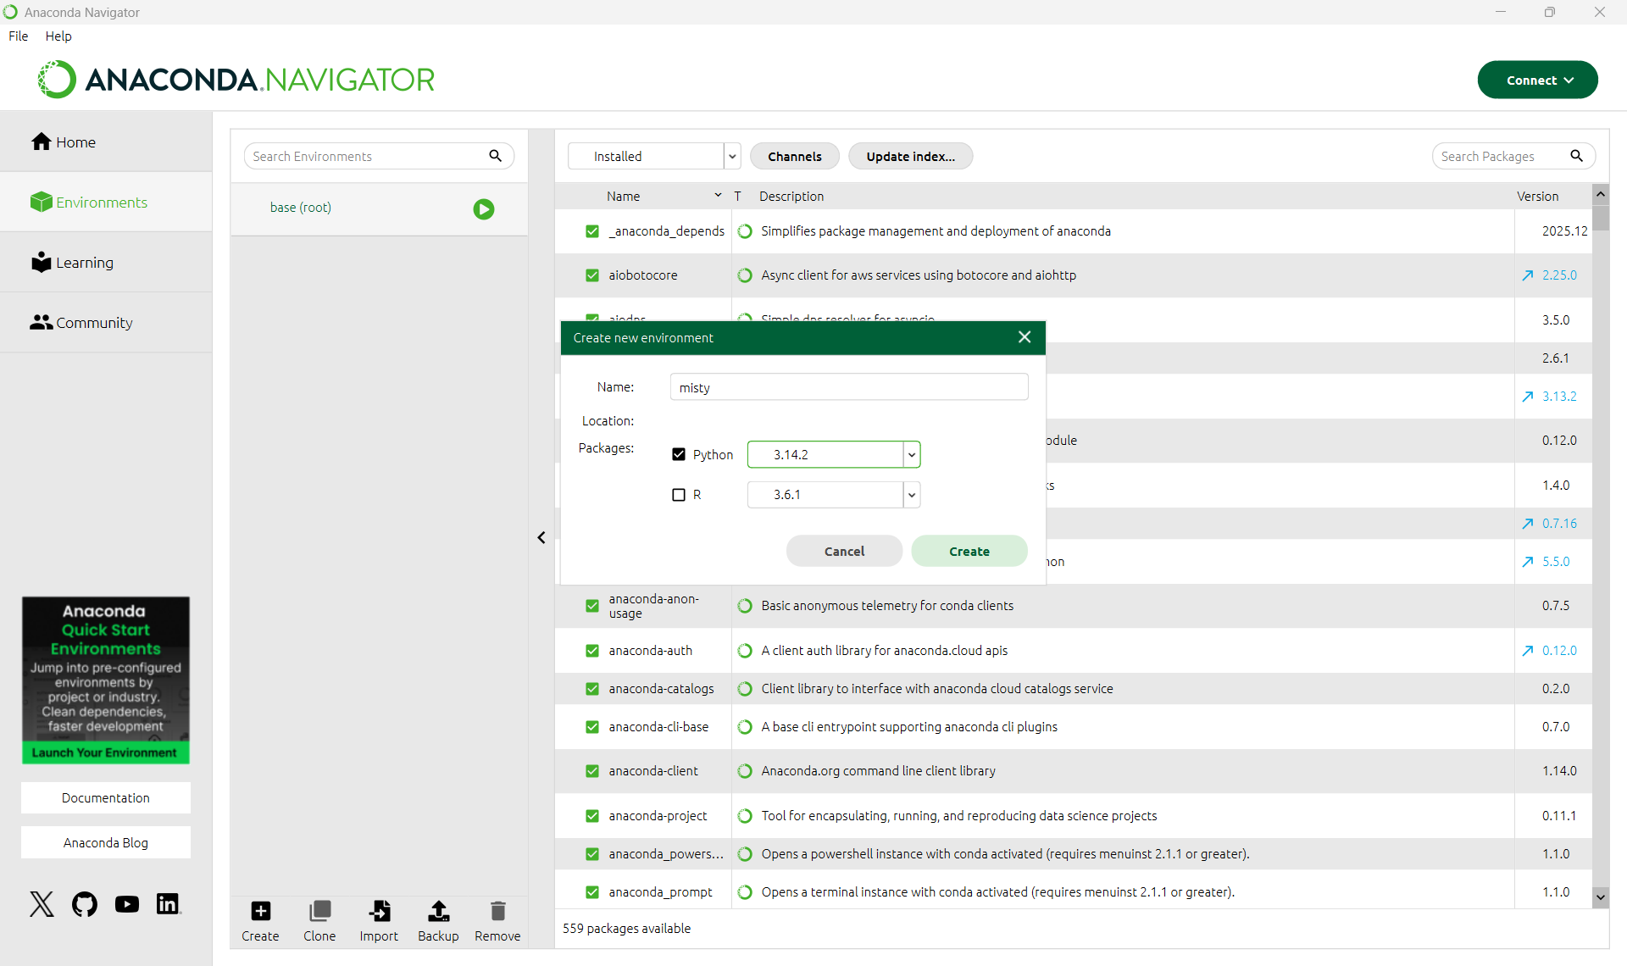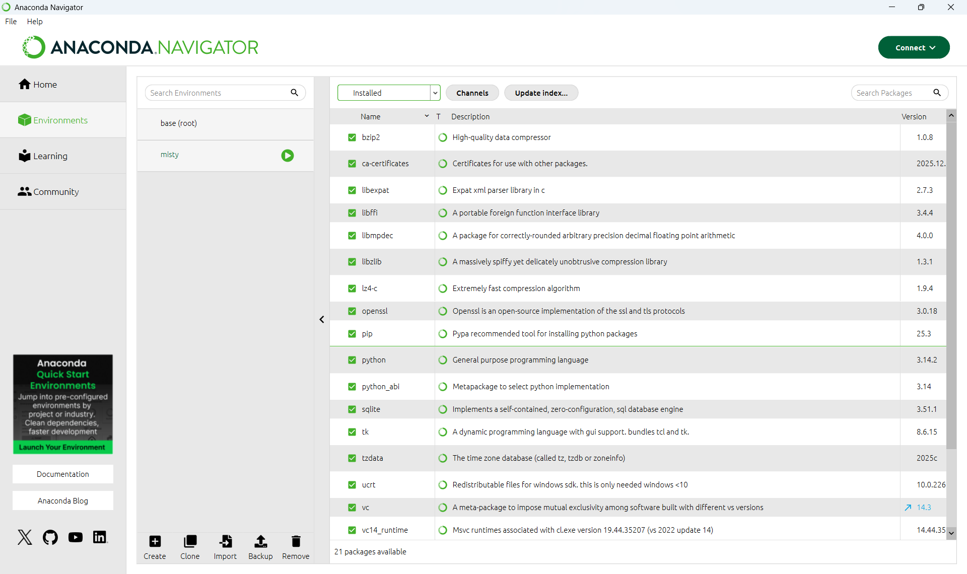
3.13

Go to home, and press “Install” on “anaconda_prompt”, “Jupyter notebook”, and “Spyder” (Spyder not in picture, but similar process)
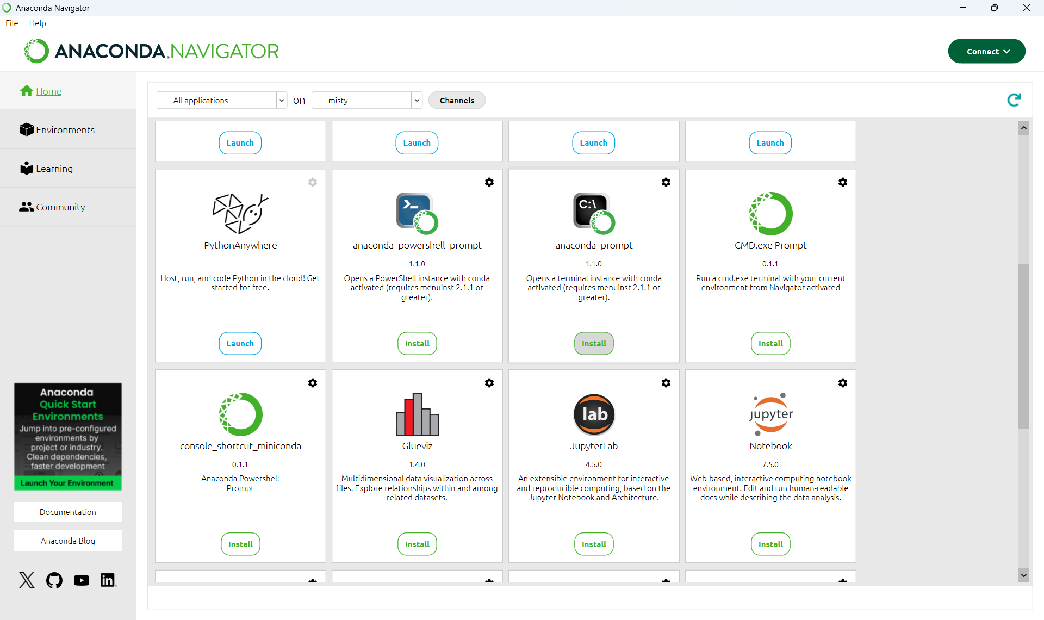

Start “anaconda_prompt”
install git by typing the following command:
conda install anaconda::git
conda install spyder-notebook –c conda-forge
install mistyPy:
pip install git+https://github.com/MistyCommunity/Python-SDK.git
Do not use “pip install mistyPy”, it is outdated
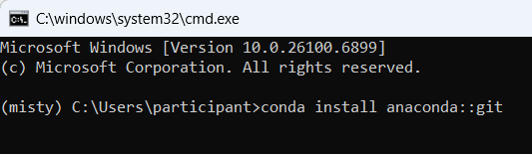
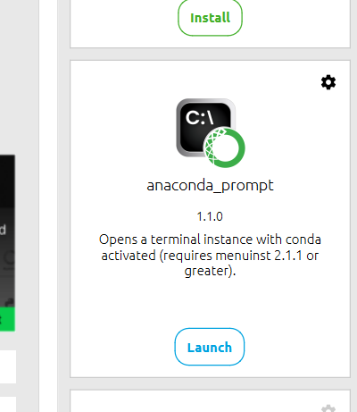

Start Spyder-notebook and test!
Open Anaconda Manager
Select the correct environment in “Environments” and Start “Spyder” in “Home”
“Undock” the spyder-notebook pane (see image)
Open the example code
https://github.com/Rctue/misty-lib/blob/main/basic_example.ipynb
Pop out the Spyder-Notebook pane and open the basic example notebook

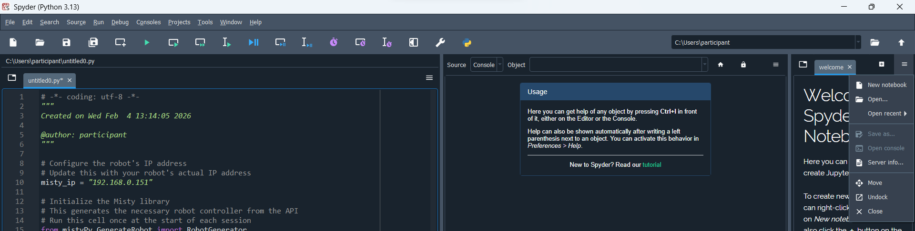

Check if you can use Misty
Is no one else working with Misty?
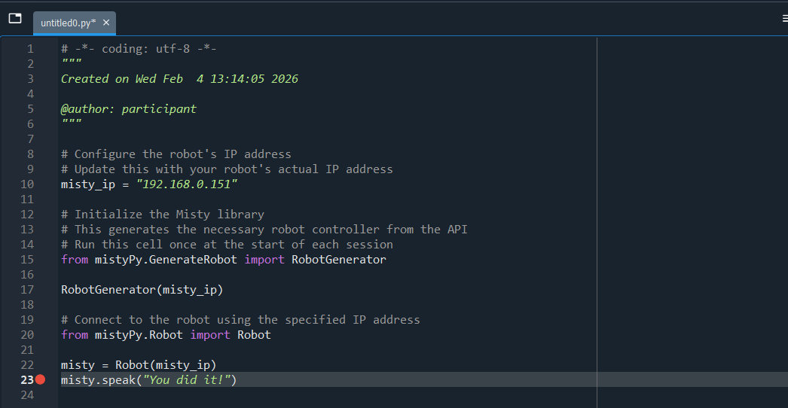
Work through the Spyder-notebook
Can you make it work in a normal .py file?

